|  |  |
| --- | --- |
| **Ex. No. 2** | **Working with HTML5 Form and Media Elements** |
| **Date of Exercise** | 17-12-2022 |

**Aim**

Build a site that conforms to HTML5 standards and has the following elements: doctype, html, meta (in the revised html5 format), title, body, head, div, p, headings, image, anchor, table, audio, video, iframe form, input, select, progress, fieldset, label, html comment.

**Description**

|  |  |
| --- | --- |
| [<audio>](https://www.w3schools.com/TAGS/tag_audio.asp) | Defines sound content |
| [<source>](https://www.w3schools.com/TAGS/tag_source.asp) | Defines multiple media resources for media elements (<video>, <audio> and <picture>) |
| [<track>](https://www.w3schools.com/TAGS/tag_track.asp) | Defines text tracks for media elements (<video> and <audio>) |
| [<video>](https://www.w3schools.com/TAGS/tag_video.asp) | Defines a video or movie |
| [<a>](https://www.w3schools.com/TAGS/tag_a.asp) | Defines a hyperlink |
| [<form>](https://www.w3schools.com/TAGS/tag_form.asp) | Defines an HTML form for user input |
| [<input>](https://www.w3schools.com/TAGS/tag_input.asp) | Defines an input control |
| [<textarea>](https://www.w3schools.com/TAGS/tag_textarea.asp) | Defines a multiline input control (text area) |
| [<button>](https://www.w3schools.com/TAGS/tag_button.asp) | Defines a clickable button |
| [<select>](https://www.w3schools.com/TAGS/tag_select.asp) | Defines a drop-down list |
| [<optgroup>](https://www.w3schools.com/TAGS/tag_optgroup.asp) | Defines a group of related options in a drop-down list |
| [<option>](https://www.w3schools.com/TAGS/tag_option.asp) | Defines an option in a drop-down list |
| [<label>](https://www.w3schools.com/TAGS/tag_label.asp) | Defines a label for an <input> element |
| [<fieldset>](https://www.w3schools.com/TAGS/tag_fieldset.asp) | Groups related elements in a form |
| [<legend>](https://www.w3schools.com/TAGS/tag_legend.asp) | Defines a caption for a <fieldset> element |
| [<datalist>](https://www.w3schools.com/TAGS/tag_datalist.asp) | Specifies a list of pre-defined options for input controls |
| [<output>](https://www.w3schools.com/TAGS/tag_output.asp) | Defines the result of a calculation |

**Program**

1. Index.html

<!DOCTYPE html>

<html>

<head>

<title>Web Technology Experiment-2</title>

</head>

<style>

.header{

background:rgb(12, 240, 244);

text-align: center;

font-size: 30px;

font-weight:bold;

height: 50px;

width:100%;

padding: 25px;

}

body{

background-image:url("background.jpg");

background-size: cover;

background-position: center;

}

.menu-bar{

background: hsl(0, 8%, 79%);

text-align: center;

width: 100%;

}

.menu-bar ul{

display: inline-flex;

list-style: none;

color:black;

}

.menu-bar ul li{

width: 220px;

padding: 5px;

}

.menu-bar ul li a{

text-decoration: none;

color: black;

font-weight: bold;

}

.menu-bar ul li:hover

{

background: rgba(236, 215, 27, 0.589);

border-radius:4px;

}

.footer

{

text-align: center;

padding: 30px;

background-color:black;

color: rgb(255, 255, 255);

height: 130px;

}

div h2{

color: white;

}

div label{

color: white;

}

</style>

<body>

<div class="header"><img src="download.png" width="50px"

height="50px">&nbsp;&nbsp;CAKE WORLD</div>

<div class="menu-bar">

<ul>

<li><a href="#">Home</a></li>

<li><a href="#">About</a></li>

<li><a href="#">Clients</a></li>

<li><a href="#">Training</a></li>

<li><a href="#">Contact</a></li>

</ul>

</div>

<video style="margin-left:44%;margin-top:2%" width="720" height="440"

controls>

<source src="cake.mp4" type="video/mp4">

</video>

<div style="margin-left: 10%;margin-top:-20%;">

<h2>Sign up</h2>

<label for="name">USERNAME&nbsp;&nbsp;</label><input type="name" name="name" placeholder="Username"><br><br>

<label for="pd">PASSWORD&nbsp;&nbsp;</label><input type="password" name="pd" placeholder="password"><br><br>

<button class="btnn"><a href="ex2(form).html" target="_blank">Register</a></button>

</div>

<audio style="margin-left: 69%;margin-top:10%" controls>

<source src="sound.ogg" type="audio/ogg">

</audio>

<p style="color:white;margin-left:7%;"><br>

<br>

Our adventure started with one humble shop in Chennai, tamilnadu.<br>Then,developed to more than one thousand areas all through the tamilnadu under the moving vision of our owner.<br>

From that point forward, our family has joined their long periods of involvement with the vision of a network of<br> cooperative shop proprietors, providers, and different accomplices cooperating to make a brand name in the market to<br> develop their business to what it is today.

So as to accomplish this, the family offers establishments to growing business visionaries and merchants joining<br> forces with them to guarantee achievement and perfection. . We bake happiness for you in the face of cake. Let us deliver sweetness in your lives<br>

</p>

<footer class="footer">

<p>2Sai Swaroop Apartments, Valluvar Salai,<br> Azhakapuri Nagar, Ramapuram, Chennai,<br> Tamil Nadu-600089</p><br>

EMAIL:&nbsp;&nbsp;<a href="mailto:dhanushkn20@karunya.edu.in" style="text-decoration: none;">dhanushkb20@karunya.edu.in</a><br>

PHONE:&nbsp;&nbsp;<a href="tel:9025321821" style="text-decoration: none;">9025321821</a>

<p class="map" style="margin-left:55%;margin-top: -9%;"><iframe src="https://www.google.com/maps/embed?pb=!1m18!1m12!1m3!1d248818.67579019564!2d79.94292063281249!3d12.9851637!2m3!1f0!2f0!3f0!3m2!1i1024!2i768!4f13.1!3m3!1m2!1s0x3a5261712f5259c9%3A0x6773fa31b259ade6!2sThe%20Cake%20World!5e0!3m2!1sen!2sin!4v1671212472202!5m2!1sen!2sin" width="250" height="130" style="border:0;" allowfullscreen="" loading="lazy" referrerpolicy="no-referrer-when-downgrade"></iframe></p>

</footer>

</body>

</html>

**Form.html**

<!DOCTYPE html>

<head>

<title>Document</title>

</head>

<body style="background-color: aqua;">

<h1 align="center">Resume Form</h1>

<form style="text-align: justify;">

<fieldset>

<legend align="center">Personal details</legend>

<p align="center">

<label for="fname">First Name:&nbsp;&nbsp;&nbsp;&nbsp;&nbsp;&nbsp;</label>

<input type="text"id="fname" required></p>

<p align="center">

<label for="mname">Middle Name:&nbsp;&nbsp;</label>

<input type="text"id="mname" required></p>

<p align="center">

<label for="lname">Last Name:&nbsp;&nbsp;&nbsp;&nbsp;&nbsp;&nbsp;</label>

<input type="text"id="lname" required></p>

<p align="center">

<label for="dob">Date of Birth:&nbsp;&nbsp;</label>

<input type="date"id="dob" required></p>

<p align="center">

<label for="age">Age in Years:&nbsp;&nbsp;</label>

<input type="number"id="age"placeholder="" required></p>

<p align="center">

Gender:<input type="radio"id="male"name="gender">

<label for="male">Male</label>

<input type="radio"id="female"name="gender" required>

<label for="female">Female</label></p></fieldset>

<fieldset>

<legend align="center">Address details</legend>

<address align="center">

<label for="Address">Address:&nbsp;&nbsp;&nbsp;&nbsp;&nbsp;&nbsp;&nbsp;&nbsp;</label>

<input type="Address"id="message" required></address>

<p align="center">

<label for="city">City/Town:&nbsp;&nbsp;&nbsp;&nbsp;</label>

<input type="text"id="city" required></p>

<p align="center">

<label for="state">State:&nbsp;&nbsp;&nbsp;&nbsp;&nbsp;&nbsp;&nbsp;&nbsp;&nbsp;&nbsp;&nbsp;&nbsp;&nbsp;</label>

<input type="text"id="state" required></p>

<p align="center">

<label for="Zip code">Date of Birth:</label>

<input type="number"id="Zip code" required></p>

</fieldset>

<fieldset>

<legend align="Center">Contact information</legend>

<p align="center">

<label for="Telephone">Telephone:</label>

<input type="tel"id="Phone" required></p>

<p align="center">

<label for="Phone">Mobile:&nbsp;&nbsp;&nbsp;&nbsp;&nbsp;</label>

<input type="tel"id="phone" required></p>

<p align="center">

<label for="Email">Email:&nbsp;&nbsp;&nbsp;&nbsp;&nbsp;&nbsp;&nbsp;</label>

<input type="email"id="email" required></p>

<p align="center">

<label for="website">website:&nbsp;&nbsp;&nbsp;&nbsp;</label>

<input type="url"id="website" required></p></fieldset>

<fieldset>

<legend align="center">Educational Details</legend>

<table border="3"align="center">

<tr bgcolor="#cccccc">

<th>Qualification</th>

<th>Board/University</th>

<th>Country</th>

<th>Starting Years</th>

<th>Ending Year</th>

<th>Percentage</th></tr>

<tr>

<td style="background-color: white;"><input type="checkbox">10th</td>

<td><input type="text"placeholder="Borad/University" required></td>

<td>

<select name="country"id="country">

<option value="choose">Choose</option>

<option value="India">India</option>

<option value="England">England</option>

<option value="South Africa">South Africa</option>

<option value="Australia">Australia</option>

</select>

</td>

<td><input type="date"></td>

<td><input type="date"></td>

<td><input type="number"placeholder="in %" required></td>

</tr>

<tr bgcolor="white">

<td bgcolor="white"><input type="checkbox">12th</td>

<td bgcolor="white"><input

type="text"placeholder="Borad/University"></td>

<td bgcolor="white">

<select name="country"id="country">

<option value="choose">Choose</option>

<option value="India">India</option>

<option value="England">England</option>

<option value="South Africa">South Africa</option>

<option value="Australia">Australia</option></select>

</td>

<td bgcolor="white"><input type="date"></td>

<td bgcolor="white"><input type="date"></td>

<td bgcolor="white"><input

type="number"placeholder="in %"></td></table>

</fieldset>

<fieldset>

<p align="center">Attach your Resume in .doc or .pdf format:<input

type="file"name="resume"></p>

<p align="center"><input type="checkbox">I fill all the

details</p></fieldset>

<p align="center">

<input type="submit"name="send details" required></p>

</form>

</body>

</html>

**Output Screenshots**

1. Index.html

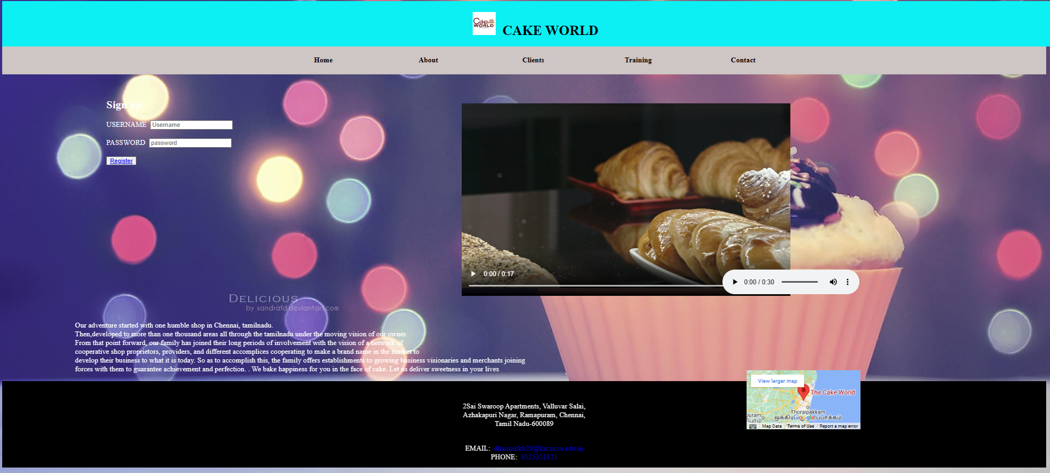

1. Form.html

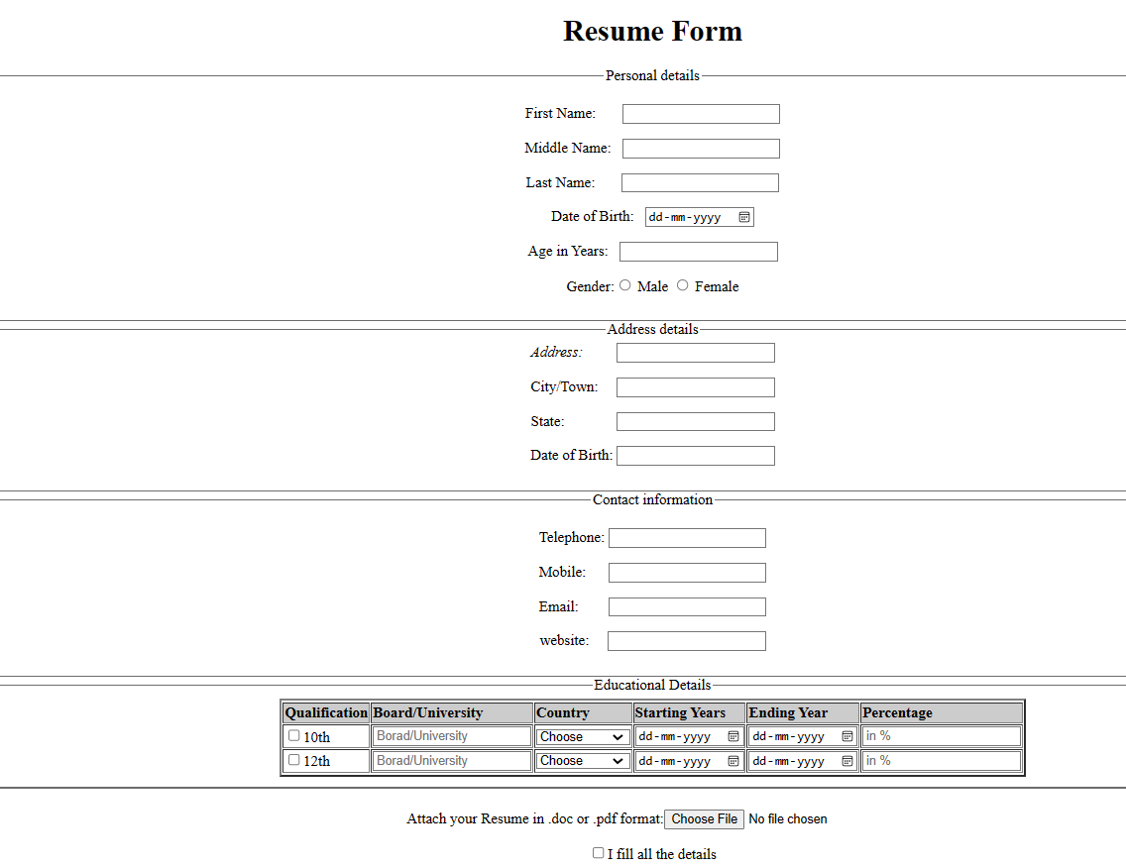

**Result**

The website is built with HTML successfully.